3.1 Insert records from 42_District_wise_crimes_committed_against_women_2001_2012.csv into a table

Answer:-

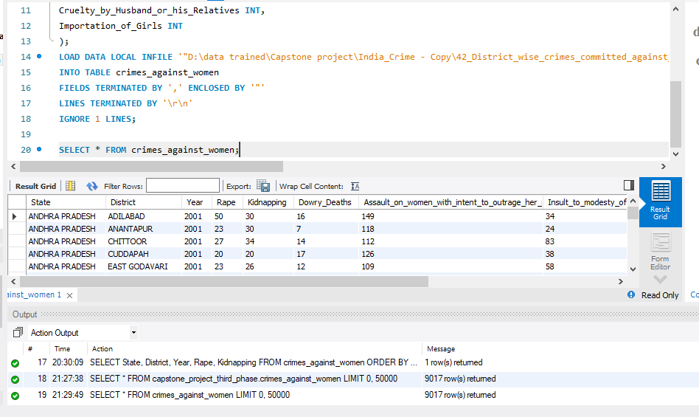

3.2 Write SQL query to find the highest number of rapes & Kidnappings that happened in which state, District, and year

Answer:-

Here I had to use 2 queries because State name of highest Rape and Kidnapping Is different.

**Query:-** SELECT State, District, Year, Rape, Kidnapping

FROM crimes_against_women

ORDER BY Rape DESC

LIMIT 1;

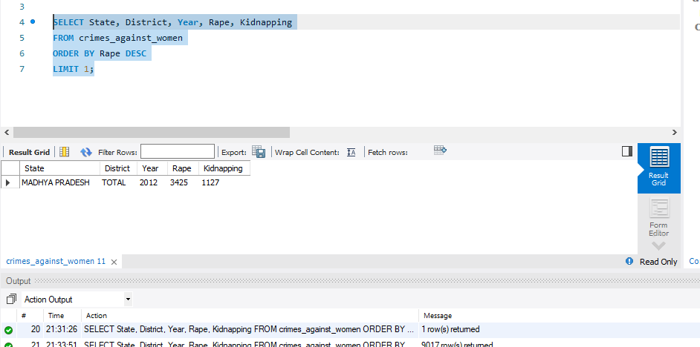

**Query:-** SELECT State, District, Year, Rape, Kidnapping

FROM crimes_against_women

ORDER BY Kidnapping DESC

LIMIT 1;

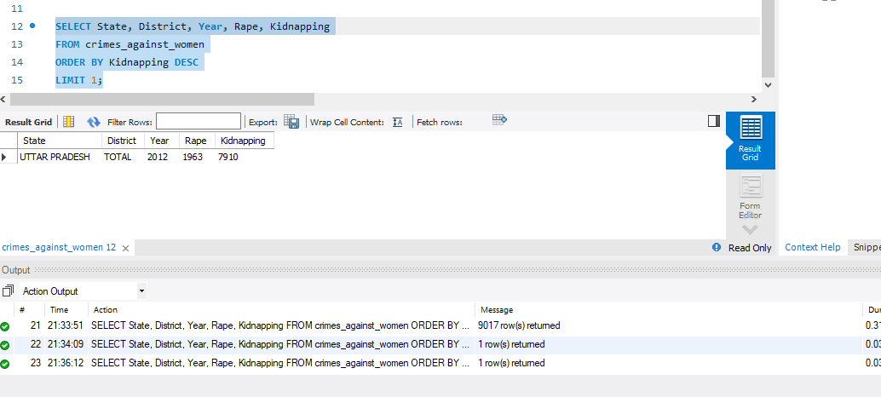

3.3 Write SQL query to find All the lowest number of rapes & Kidnappings that happened in which state, District, and year

Answer:-

**Query:-** SELECT State, District, Year, Rape, Kidnapping

FROM crimes_against_women

ORDER BY Rape,Kidnapping

LIMIT 1;

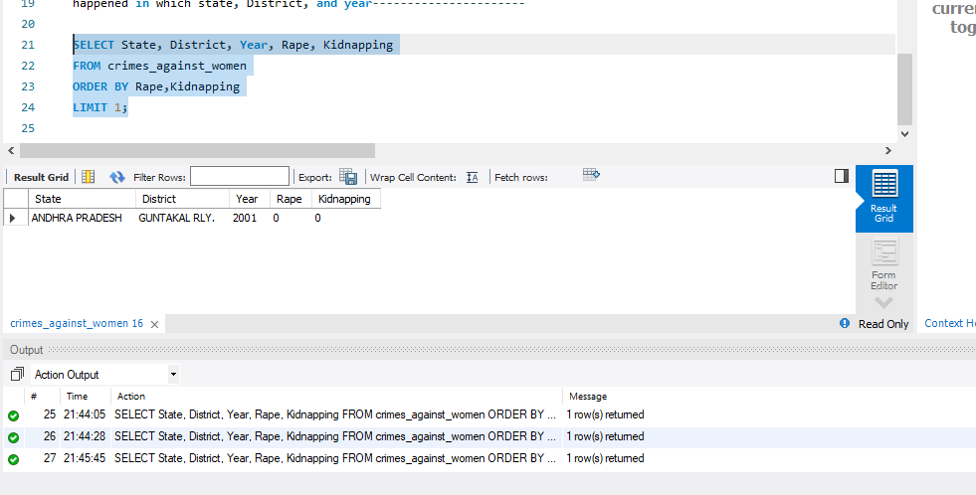

Here I fetched the data with Rape and Kidnapping values with the state, District, and year

3.4 Insert records from 02_District_wise_crimes_committed_against_ST_2001_2012.csv into a new table

Answer:-

**Query:-** CREATE TABLE District_wise_crimes_committed_against_ST (

STATE VARCHAR(20),

DISTRICT VARCHAR(40),

Year INT,

Murder INT,

Rape INT,

Kidnapping INT,

Dacoity_Robbery_Arson INT,

Hurt INT,

Protection_of_Civil_Rights_PCR_Act INT,

Prevention_of_atrocities_POA_Act INT,

Other_Crimes_Against_STs INT

);

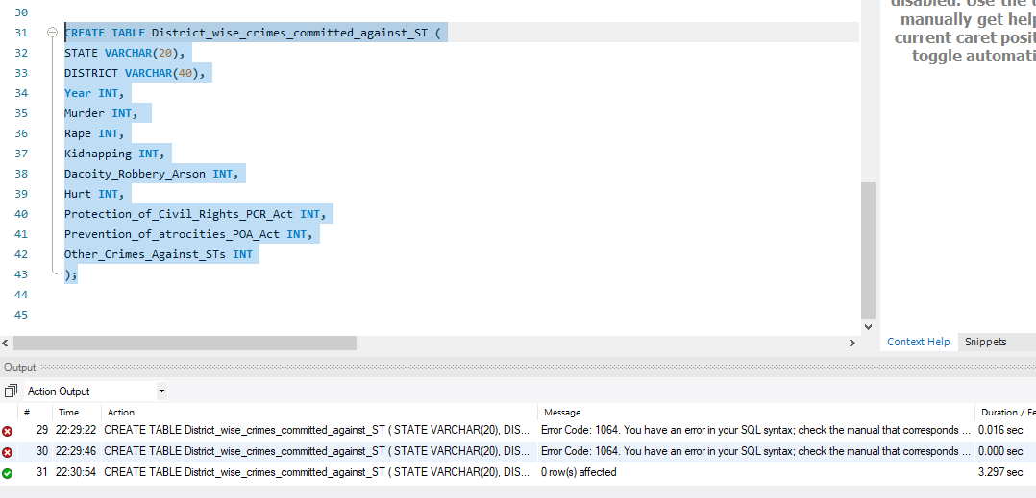

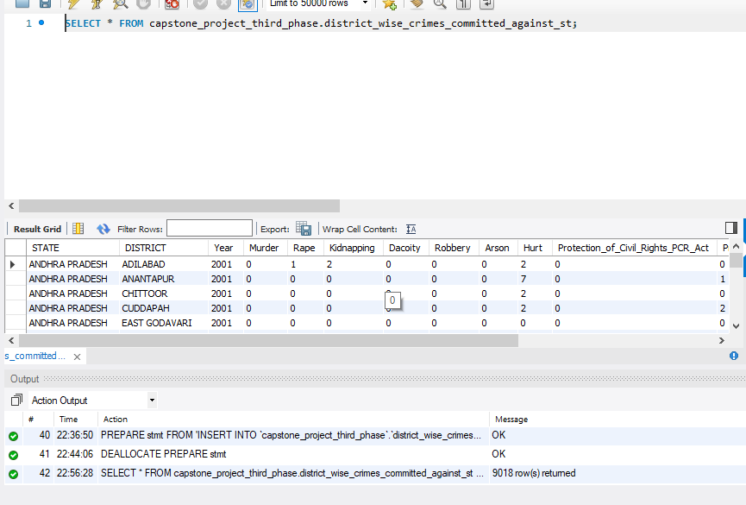

3.5 Write SQL query to find the highest number of dacoity/robbery in which district.

Answer:-

Here two questions are present: -

**Query: -** SELECT DISTRICT,SUM(Dacoity) AS Total_Dacoity

FROM

district_wise_crimes_committed_against_st

WHERE DISTRICT != "TOTAL"

GROUP BY

DISTRICT

ORDER BY

Total_Dacoity DESC

LIMIT 1;

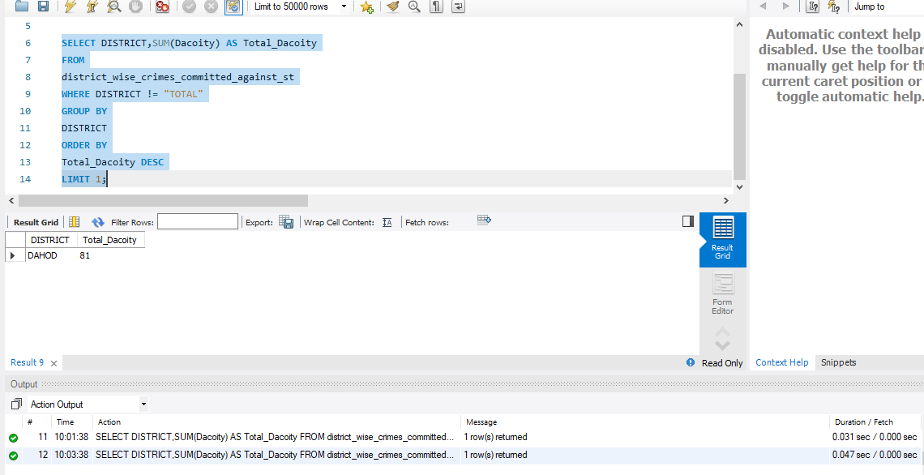

**Query: -** SELECT DISTRICT,SUM(Robbery) AS Total_Robbery

FROM

district_wise_crimes_committed_against_st

WHERE DISTRICT != "TOTAL"

GROUP BY

DISTRICT

ORDER BY

Total_Robbery DESC

LIMIT 1;

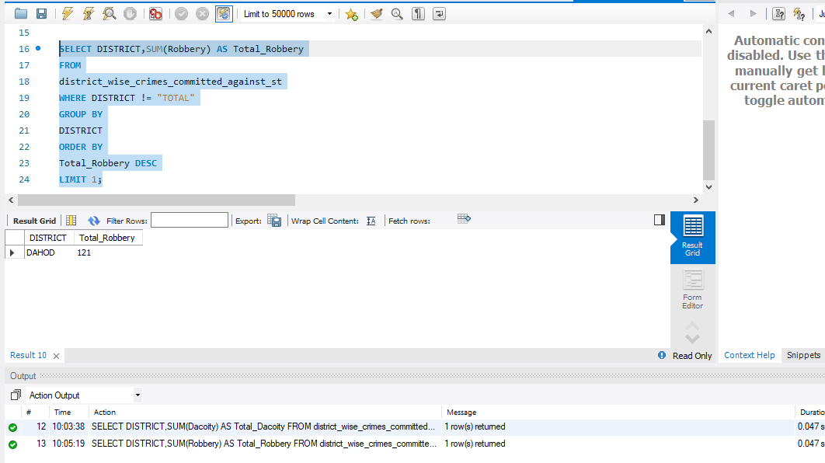

3.6 Write SQL query to find in which districts(All) the lowest number of murders happened

Ans:-

**Query: -**SELECT DISTRICT,SUM(Murder) AS Total_Murder

FROM

district_wise_crimes_committed_against_st

WHERE DISTRICT != "Total"

GROUP BY

DISTRICT

ORDER BY

Total_Murder

LIMIT 1;

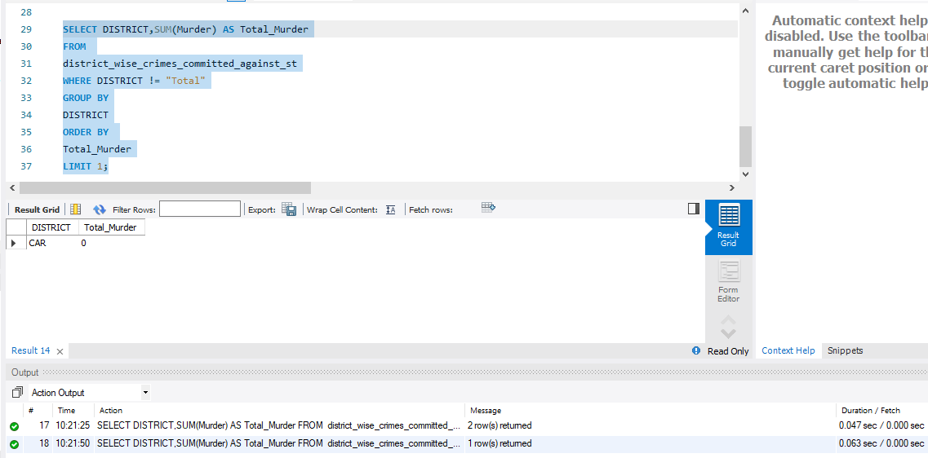

3.7 Write SQL query to find the number of murders in ascending order in district and year wise.

Ans:-

**Query: -** SELECT DISTRICT,Year,SUM(Murder) AS Total_Murder

FROM

district_wise_crimes_committed_against_st

GROUP BY

DISTRICT,Year

ORDER BY

Total_Murder ASC;

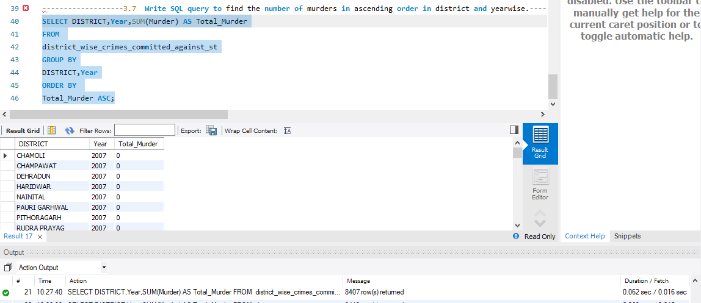

3.8.1 Insert records of STATE/UT, DISTRICT, YEAR, MURDER, ATTEMPT TO MURDER, and RAPE columns only from 01_District_wise_crimes_committed_IPC_2001_2012.csv into a new table

Ans: -

**Query: -** CREATE TABLE District_wise_crimes_committed_IPC_2001_2012 (

STATE VARCHAR(20),

DISTRICT VARCHAR(30),

YEAR INT,

MURDER INT,

ATTEMPT_TO_MURDER INT,

CULPABLE_HOMICIDE_NOT_AMOUNTING_TO_MURDER INT,

RAPE INT,

CUSTODIAL_RAPE INT,

OTHER_RAPE INT,

KIDNAPPING INT,

KIDNAPPING_AND_ABDUCTION_OF_WOMEN_AND_GIRLS INT,

KIDNAPPING_AND_ABDUCTION_OF_OTHERS INT,

DACOITY INT,

PREPARATION_AND_ASSEMBLY_FOR_DACOITY INT,

ROBBERY INT,

BURGLARY INT,

THEFT INT,

AUTO_THEFT INT,

OTHER_THEFT INT,

RIOTS INT,

CRIMINAL_BREACH_OF_TRUST INT,

CHEATING INT,

COUNTERFIETING INT,

ARSON INT,

HURT_GREVIOUS_HURT INT,

DOWRY_DEATHS INT,

ASSAULT_ON_WOMEN_WITH_INTENT_TO_OUTRAGE_HER_MODESTY INT,

INSULT_TO_MODESTY_OF_WOMEN INT,

CRUELTY_BY_HUSBAND_OR_HIS_RELATIVES INT,

IMPORTATION_OF_GIRLS_FROM_FOREIGN_COUNTRIES INT,

CAUSING_DEATH_BY_NEGLIGENCE INT,

OTHER_IPC_CRIMES INT,

TOTAL_IPC_CRIMES INT);

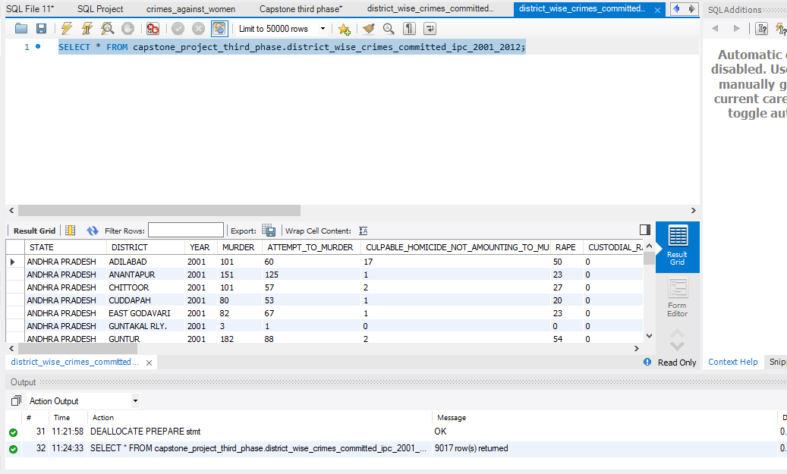

3.8.2 Write SQL query to find which District in each state/ut has the highest number of murders yearwise. Your output should show STATE/UT, YEAR, DISTRICT, and MURDERS.

Ans:-

**Query: -** WITH TotalDistricts AS (

SELECT *

FROM district_wise_crimes_committed_ipc_2001_2012

WHERE DISTRICT = 'TOTAL'

),

MaxMurderDistricts AS (

SELECT

STATE,

YEAR,

DISTRICT,

MURDER AS MURDERS,

ROW_NUMBER() OVER (PARTITION BY STATE, Year ORDER BY Murder DESC) AS RowNum

FROM district_wise_crimes_committed_ipc_2001_2012

WHERE DISTRICT != 'TOTAL' -- Exclude rows where DISTRICT is "TOTAL"

)

SELECT STATE, YEAR, DISTRICT, MURDERS

FROM MaxMurderDistricts

WHERE RowNum = 1;

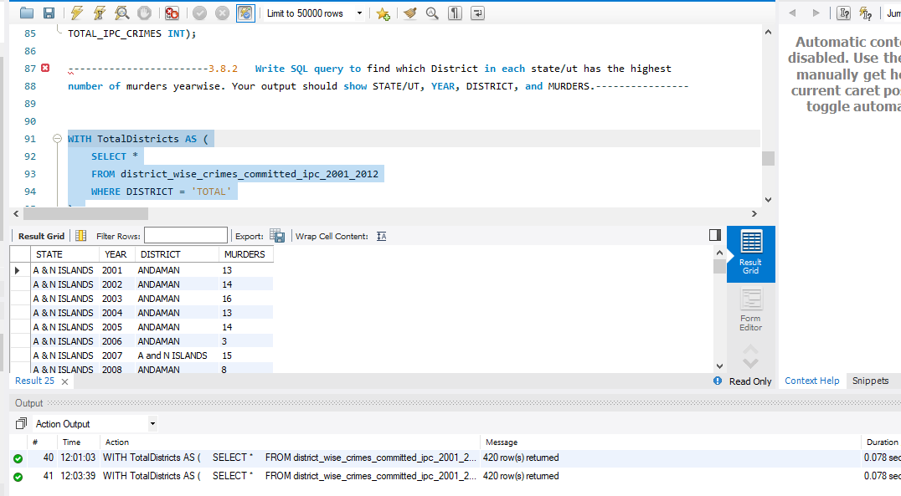

Storing the above output in a table named MaxMurderDistricts_Output then I will export the table and will make it CSV file for 3.8.3 task.

Query: - CREATE TABLE MaxMurderDistricts_Output (

STATE VARCHAR(20),

YEAR INT,

DISTRICT VARCHAR(30),

MURDERS INT

);

INSERT INTO MaxMurderDistricts_Output (STATE, YEAR, DISTRICT, MURDERS)

SELECT STATE, YEAR, DISTRICT, MURDER

FROM (

SELECT

STATE,

YEAR,

DISTRICT,

MURDER,

ROW_NUMBER() OVER (PARTITION BY STATE, Year ORDER BY Murder DESC) AS RowNum

FROM district_wise_crimes_committed_ipc_2001_2012

WHERE DISTRICT != 'TOTAL' -- Exclude rows where DISTRICT is "TOTAL"

) AS MaxMurderDistricts

WHERE RowNum = 1;

SELECT * FROM MaxMurderDistricts_Output;

Exporting the MaxMurderDistricts_Output

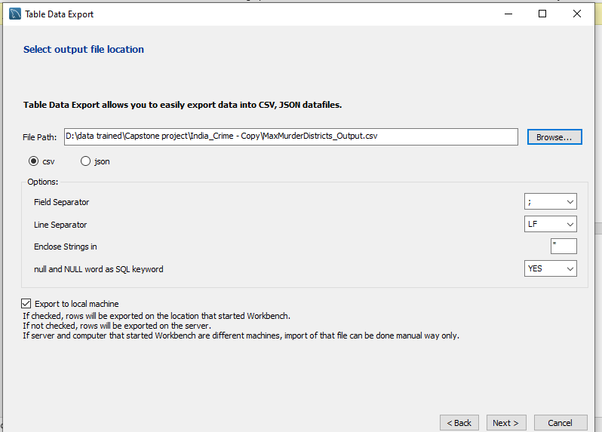

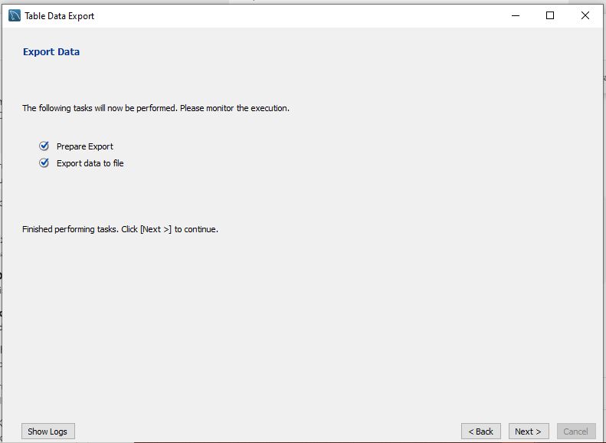

3.8.3 Store the above data (the result of 3.2) in DataFrame and analyze districts that appear 3 or more than 3 years and print the corresponding state/ut, district, murders, and year in descending order.

Ans: -

This process and rest of the answers I have to complete on Jupiter note book. So please check that out.